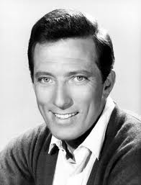
The Mixed Nuts
Set S Last revised on 2017.12.28

S01-It's A Good Day(KVF).2015.10.27.pdf
S01-It's A Good Day(KVM).2015.10.27.pdf
S02-Tell Me Why(KVF).2015.05.10.pdf
S02-Tell Me Why(KVM).2015.05.10.pdf
S03-Hello, My Baby(KVD).2015.09.20.pdf
S04-Ciribiribin(KVF).2016.09.18.pdf
S04-Ciribiribin(KVM).2016.09.18.pdf
S05-Sheik Of Araby(KV).2017.12.28.pdf
S06-Somewhere Out There(KVD).2017.12.28.pdf
S07-When My Baby Smiles At Me(KVF).2017.12.28.pdf
S07-When My Baby Smiles At Me(KVM).2017.12.28.pdf
S08-The Shadow Of Your Smile(KVF).2016.09.18.pdf
S08-The Shadow Of Your Smile(KVM).2016.09.18.pdf
S09-Born Free(KVF).pdf
S09-Born Free(KVM).pdf
S10-Days Of Wine And Roses(KVF).2015.11.16.pdf
S10-Days Of Wine And Roses(KVM).2015.11.16.pdf
S11-Good Times Polka(KV).2015.07.16.pdf
S12-Sentimental Journey(KVF).2014.01.23.pdf
S12-Sentimental Journey(KVM).2014.01.23.pdf
S13-Dipsy Doodle(KV).2017.12.28.pdf
S14-Lonely Goatherd, The(KVF).2014.03.31.pdf
S14-Lonely Goatherd, The(KVM).2014.03.31.pdf
S15-Green, Green Grass Of Home, The(KVF).2017.12.28.pdf
S15-Green, Green Grass Of Home, The(KVM).2017.12.28.pdf
S16-Standing On The Corner(KV).2013.11.05.pdf
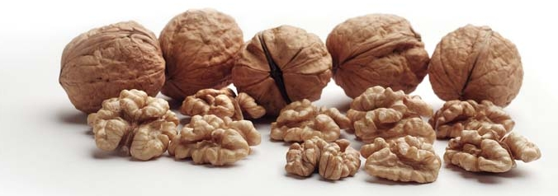
S17-I Got A Gal In Kalamazoo(KV).2015.09.20.pdf

